**ASSIGNMENT-2**

**N. MENAKA**

**610819106034**

**B.E /ECE**

TeamID-PNT2022TMID30034

**CODE:**

while 1:

    import random

    a=random.randint(0,100)

    b=random.randint(0,100)

    print("Enter Temperature",a)

    print("Enter Humidity",b)

    if a>30:

        if b>70:

            print("Alert detected")

        else:

            print("High Temperature detected")

    elif a==30:

            print("Maximum Threshold reached")

    else:

            print("EVERYTHING IS NORMAL")

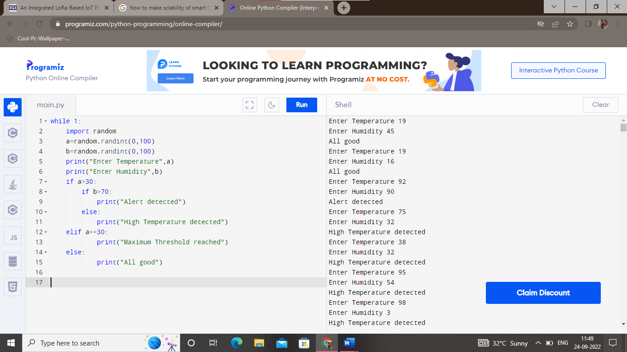**OUTPUT:**